Desert Laboratory on Tumamoc Hill
Research Project Permit Application

Instructions: Please complete the application in full (including your signature) and send to desertlaboratory@gmail.com as a Word file. The Desert Laboratory will review and follow up with questions. If your permit is approved, we will sign and return it to you for your signature.

SUBMISSION DATE: _____________________

PROJECT NAME:

PROJECT LEADER:
(Additional project participants are listed on page 5 of this application)

Institution or organization name:
Name of Project Leader (or Instructor):
Phone:
Email:
Address:
Vehicle License Plate Make, Model, and License Plate Number:

RESEARCH PROJECT DATES:
Project initiation date:

Project completion date:

ACTIVITIES POTENTIALLY REQUIRING SPECIAL PERMITS:
If applicable, please initial on the adjacent line and provide details.
_____ Does the proposed research involve feeding, trapping, or handling of live
animals?
IACUC Application Date____________
IACUC Protocol Number________________

_____ Does the proposed research involve surface or subsurface disturbance?

_____ Will the proposed research involve collecting or manipulating plant samples?

_____ Are human subjects involved?
Human Subjects Assurance Number__________
Exemption Subsection_______________ or IRB Application Date___________

_____ Will equipment be installed on site?

_____ Will any Tumamoc building space or facilities be required?

_____ All appropriate permits have been obtained from the Human Subjects Protection Program and from the Institutional Biosafety Committee and Institutional Animal Care and Use Committee and are up to date. The Human Subjects Protection Program (vpr-irb@email.arizona.edu) must be contacted for any activities involving human subjects. The IACUC (orcr-iacuc@email.arizona.edu) must be contacted for any activities involving vertebrate animals.

AGREEMENTS:
Please initial to indicate your agreement to each of the following rules and guidelines for conducting research on Tumamoc Hill.
_____ Researchers MUST remove ALL equipment and markings at the end of the study except by prior arrangement. Failure to do so will result in fees.
_____ Researchers MUST provide a copy of all publications resulting from the research conducted on Tumamoc Hill.
_____ Research publications and spatial data that identify the locations of research activities and observations (species counts, cultural resource occurrences, etc.) MUST be provided. If research is conducted on County property, this information MUST be sent to Pima County’s Office of Sustainability and Conservation (Ian.Milliken@pima.gov).
_____ Researchers MUST notify the Tumamoc Hill staff of any subsequent funding awards received to undertake similar or related research to the submitted project as part of our effort to quantify the impact of research undertaken at Tumamoc Hill.
_____ All project participants must attend an orientation meeting with Tumamoc staff before beginning any work at Tumamoc.
_____ If on County property, researchers must comply with the terms of any Pima County granted right-of-entry.
_____ All project participants will complete cultural sensitivity training and a brief safety briefing before beginning research or other activities on site.

SIGNATURES REQUIRED FOR APPROVAL:

___________________________________________________ ______________
Project Leader Date

___________________________________________________ ______________
Dr. Benjamin T. Wilder Date
Director, Desert Laboratory on Tumamoc Hill
RESEARCH PROPOSAL ABSTRACT
Explain the proposed research, including research questions and objectives. Please provide details of methodology, especially pertaining to the above checklist of activities potentially requiring special permits (you can go over 1 page if necessary to explain these). If applicable, note how this study builds on previous studies and research themes of the Desert Laboratory.

FUNDING SOURCES:
If this research is funded, please let us know the name, source, amount, and number grant or contract:

ADDITIONAL RESEARCH PARTICIPANTS:
Please list all research project participants, including all graduate and undergraduate students and provide full names, titles, email address, and phone number for each individual.
PROPOSED RESEARCH LOCATION
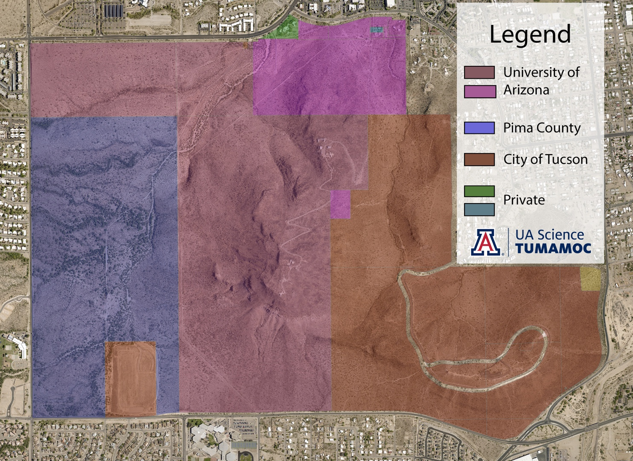
Using this map, indicate the proposed research location(s), including routes used to arrive at research location(s). If you need a more localized/detailed map, attach details as added to Google Earth or Pima County MapGuide. Also provide lat/long coordinates (NAD83).

