Desert Laboratory on Tumamoc Hill
Research Project Permit Application

Instructions: Please complete the application in full (minus your signature) and send to Dr. Larry Venable and Dr. Ben Wilder as a Word file. The Desert Laboratory staff will then sign and return to you to sign and submit to Dr. Venable and Dr. Wilder.

Submission date: _____________________

Project Name:

Project Leader:
(please attach a separate list of additional research participants after the research proposal abstract)
Institution or organization name:
Name of Project Leader (or Instructor):
Phone:
Email:
Address:

Research Project Dates:
Project initiation date:

Project completion date:

Activities potentially requiring Special Permits (if applicable please place an “X” on the adjacent line and provide details):
•___ Does the proposed research involve feeding, trapping or handling of live animals?
IACUC App. Date____________ IACUC Protocol Number________________

•___ Does the proposed research involve surface or subsurface disturbance?

•___ Will the proposed research involve collecting or manipulating of plant samples?

•___ Are human subjects involved? Human Subjects Assurance Number__________
Exemption Subsection_______________ or IRB App. Date___________

•___ Will equipment be installed on site?

•___ Will any Tumamoc building space or facilities be required?

•___All appropriate permits have been obtained from the Human Subjects Protection Program and from the Institutional Biosafety Committee and Institutional Animal Care and Use Committee and are up-to-date. The Human Subjects Protection Program (vpr-irb@email.arizona.edu) must be contacted for any activities involving human subjects. The IACUC (orcr-iacuc@email.arizona.edu) must be contacted for any activities involving vertebrate animals.

Agreements:
In conducting research on Tumamoc Hill we ask that you agree to the following:
- Researchers MUST remove ALL equipment and markings at the end of the study except by prior arrangement. Failure to do so will result in fees.
- Researches MUST provide a copy of all publications resulting from the research conducted on Tumamoc Hill
- Research publications and spatial data that identify the locations of research activities and observations (species counts, cultural resource occurrences, etc.) MUST be provided. If research is conducted on County property, this information MUST be sent to Pima County’s Office of Sustainability and Conservation (Ian.Milliken@pima.gov and Cannon.Daughtrey@pima.gov)
- Researchers MUST notify the Tumamoc Hill staff of any subsequent funding awards received to undertake similar or related research to the submitted project as part of our effort to quantify the impact of research undertaken at Tumamoc.
- All project participants must attend an orientation meeting with Tumamoc staff before beginning any work at Tumamoc.
- If on County property, researchers must comply with the terms of any Pima County granted right-of-entry.

Signatures required for approval:

___________________________________________________ Date ________________
Project Leader
___________________________________________________ Date ________________
Dr. Larry Venable
Director of Research, Desert Laboratory on Tumamoc Hill

___________________________________________________ Date _________________
Dr. Benjamin T. Wilder
Director, Desert Laboratory on Tumamoc Hill

Research Proposal Abstract
Explain the proposed research, including research questions and objectives. Please provide details of methodology, especially as pertaining to the checklist above of activities potentially requiring special permits (you can go over 1 page if necessary, to explain these). If applicable, note how this study builds on previous studies and research themes of the Desert Laboratory.

Funding Sources:
If this research is funded, please let us know the name, source, amount, and number grant or contract:

Additional research participants:
Proposed Research Location
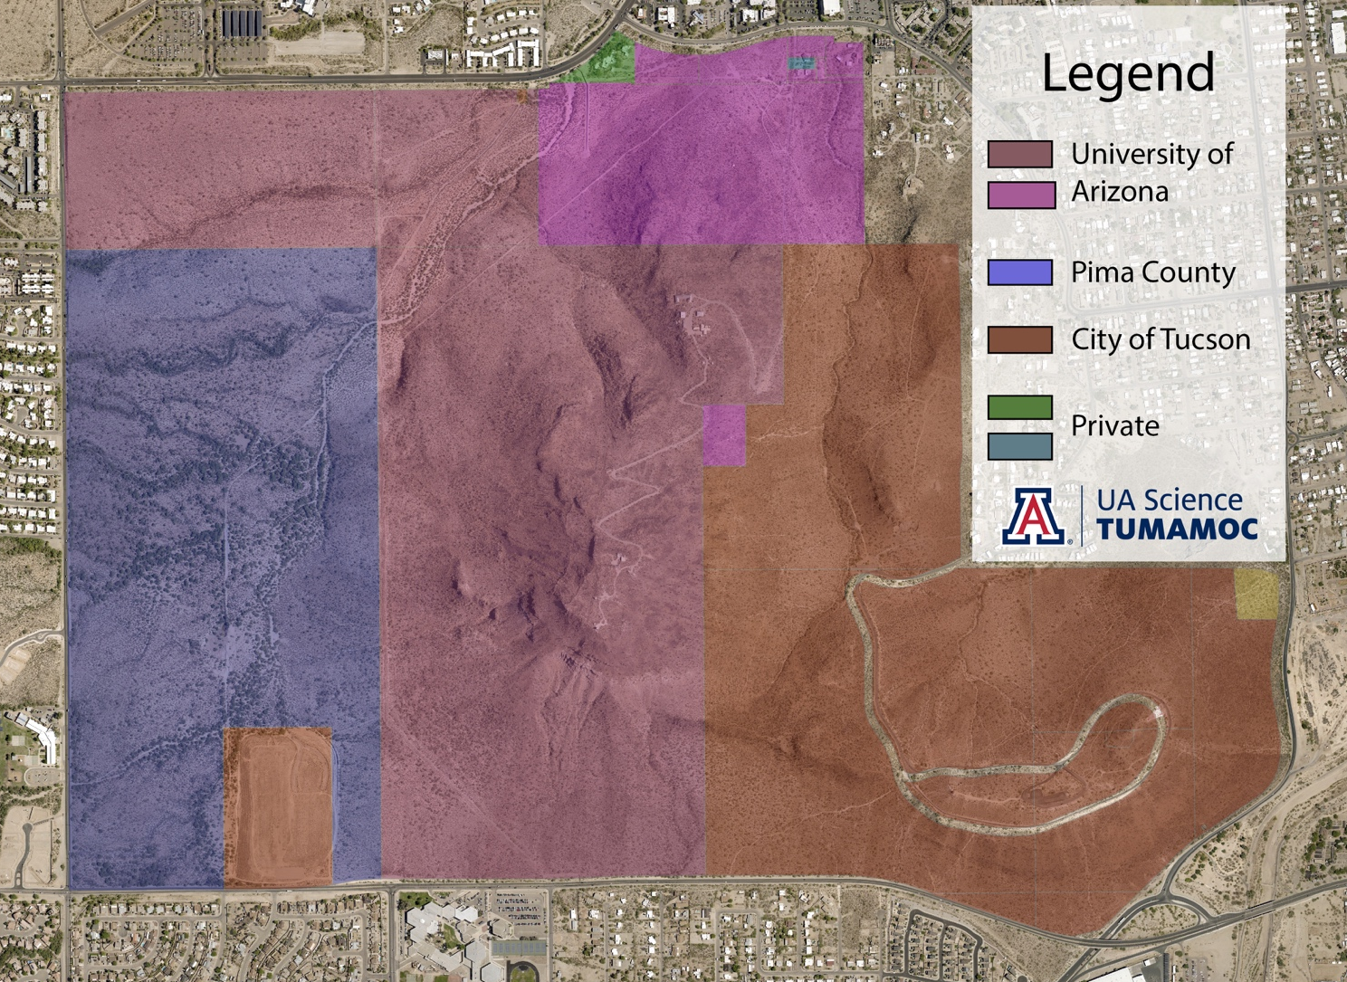
Using this map, indicate the proposed research location(s), including routes used to arrive at research location(s). If you need a more localized/detailed map, attach details as added to Google Earth or Pima Co. MapGuide. Also provide lat/long coordinates (NAD83).

